Name: Akash Barve

UFID: 55466983

Architecture:

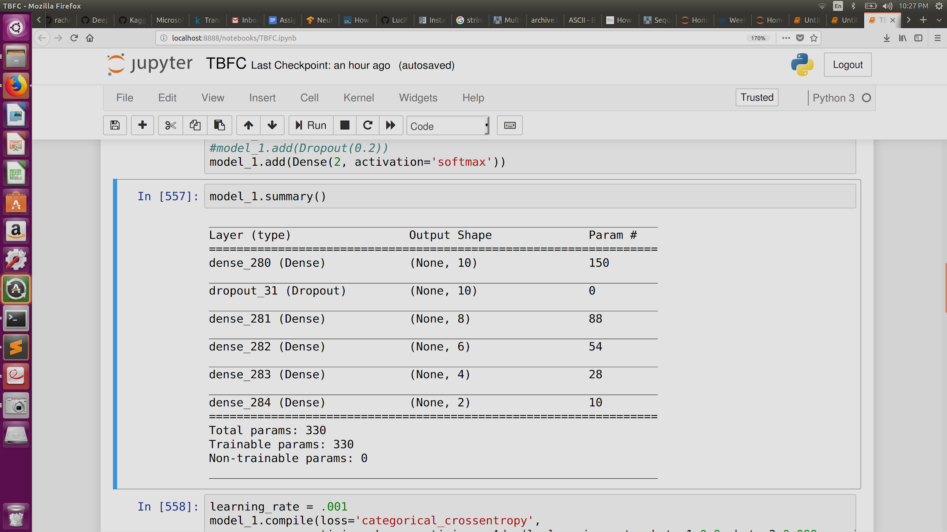

Maximum score achieved: 63.354%

Results: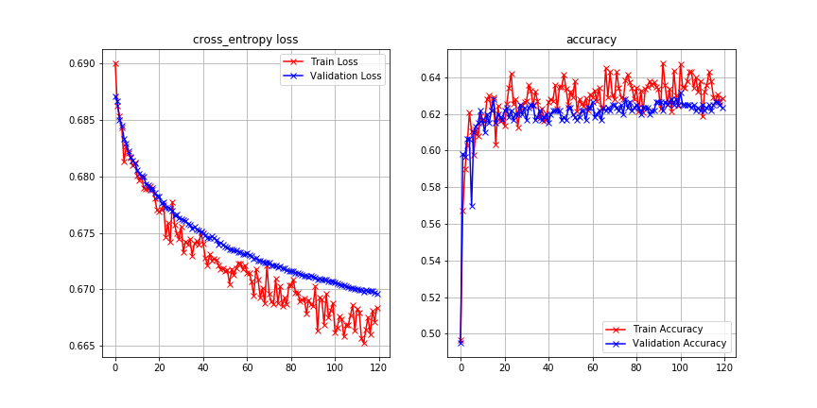

Code requirements:

* Python 3.6+
* Execute from jupyter
* pip install -r requirements.txt
* Run TFBC.py

Analysis:

The approach could not give as much accuracy as other ones on the platform. Model works bu should be made better for this use case.